Discover Hidden Art trough Augmented Reality

|  | Julia Gabajova  Middlesex University, London  Email: [JG1004@live.mdx.ac.uk](mailto:JG1004@live.mdx.ac.uk) |  |
| --- | --- | --- |

# INTRODUCTION

In Museums and Art Galleries, if a visitors want to obtain more information about the particular exhibition they can do so from the corresponding text, images and videos. However, these ways visitors cannot feel the sense of interaction or immersion with the exhibition, which are the most important factors for enjoying the exhibition and better understanding the relevant concepts.

The goal of this project was to create a mobile application which will change the gallery visitor’s experience, instead of traditional long and outdated audio guides devices, upon which Museums and Art Galleries still rely on, will replace with new Augmented Reality (AR) technology.

# Research

My team and I have decided to visit Victoria & Albert Museum and The National Gallery in London to discover some idea how to improve the visitor’s experience.

When we were in Victoria & Albert Museum, we asked the staff what are the most common questions that visitors ask and writing them down. We discovered, that most common questions asked were regarding the damaged statues. Most of the statues were repaired and complete, but some of the statues were missing big pieces as shown in Figure1 bellow. Visitors wanted to know how the statue looked before.

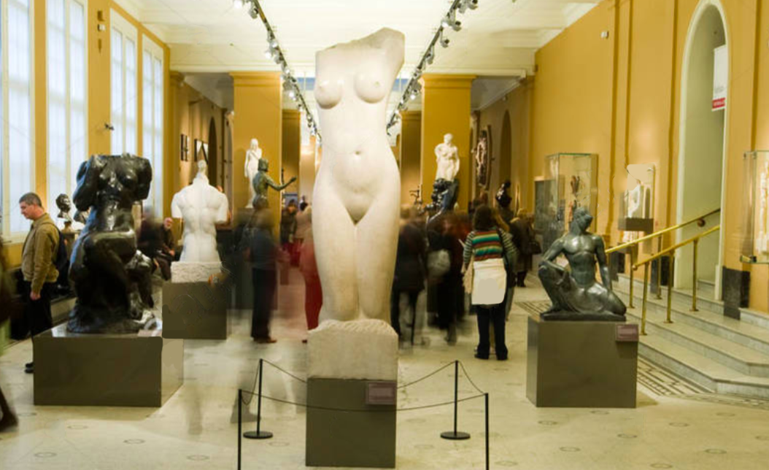

Figure 1

The second place we visited was The National Gallery. Visitors of this gallery were very interested about the history of the paintings. Most of the time, visitors had the same questions and the staff had to repeat themselves. For instance, the painting of Sunflowers by Vincent van Gogh as shown in Figure2 on the top right, visitors did not have enough space to read the extra information regarding the painting, especially on the most famous arts were people have been queuing to see more details.

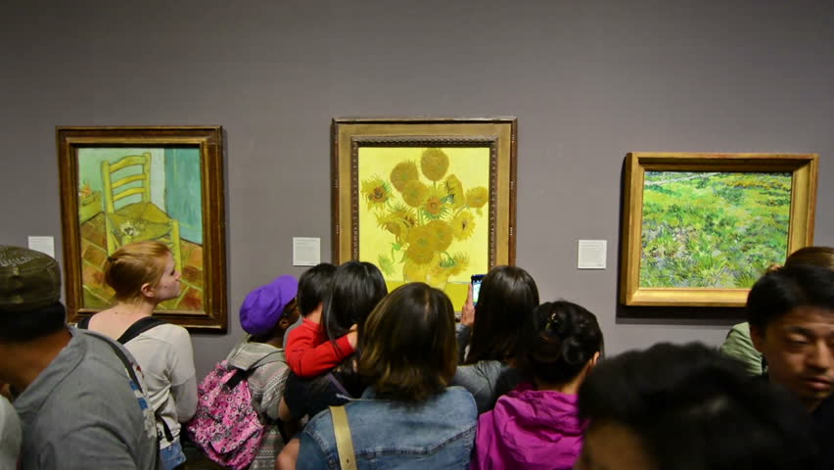

Figure 2

Visiting the V&M museum where visitors were curious how the damaged/missing parts looked like before, gave us an idea to start thinking of a design idea. We decided to provide the missing information and start doing our research part.

Our research was focused on the history of the artwork and how we could improve the better experience for visitors. Most of the Museums and Art Galleries in London do not use Augmented Reality features yet. The first Augmented reality app launched in 2018 developed by BBC Research & Development called Civilizations AR. The app features over 30 fascinating exhibits across the UK, which allows the user to view the exhibition in 3D [1]

Furthermore, I believe museums should provide even more of the interactive features for visitors. As in Washington, D.C Smithsonian’s National Museum of Natural History started using this advanced technology and engage the visitors by showing the animal’s anatomy and evolution [2].

Also, we came across Museum of London, which released an augmented reality app, not particularly used in the museums, but used as a “Streetmuseum” which allows users to browse historical photographs in different parts of London as shown in Figure3 bellow [3].

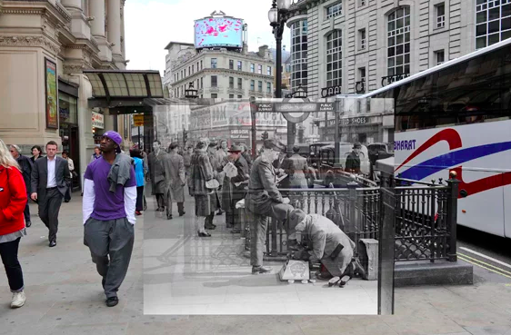

Figure 3

As Daniel said in his research “There are many myths that whisper of hidden messages left behind by these great masters for future generations. However, technology can now help us confirm these mysteries, and finally we can unveil the secrets hidden within layers of colors and textures” [4]. Sadly, this information has been just discussed on how hidden arts of a number of well know works are uncovered, but this information has not been provided in museums yet.

After all this research, my team and I agreed that there are lots of important information that the visitors will be very interested to know about and that the museums and galleries should provide this information. We decided to design an application that uncovers this hidden art.

# Design concept

From these findings, my team and I started deciding how to put all these ideas together to create an application that will be easy to use and useful for galleries or museums. This application will also be very helpful for the staff, but mostly focuses to provide extra information for visitor’s and also more exiting experience at the same time.

We decided to create mobile application, which will allow users to interact with the image they want to get more information about. They would be able to look at the image and see additional information to what’s present in the physical world. We also connected with this information by providing users with the latest discovery of hidden art.

To design this application, we decided to use a swipe function which will help the user to reveal the hidden art which was overpainted as shown in the painting of Patch of Grass by Vincent van Gogh on Figure4 bellow.

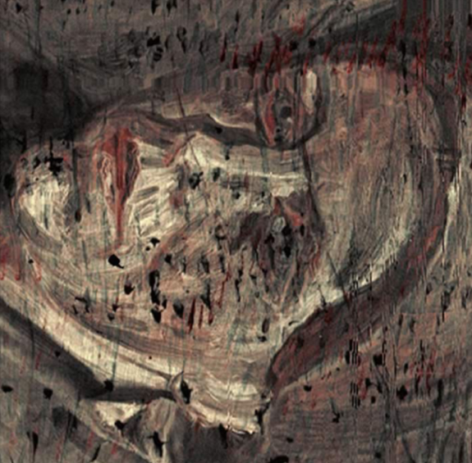

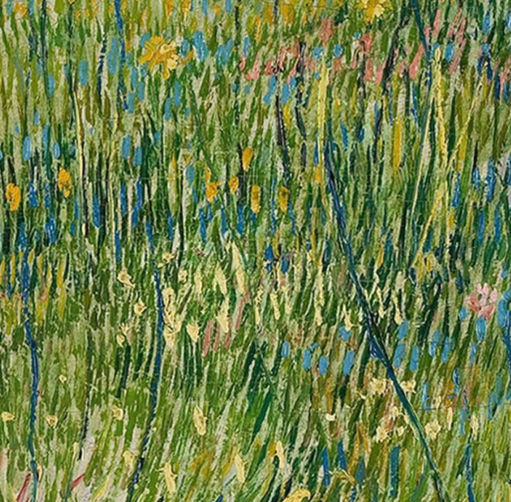

Figure 4

Swipe away

To use this application, the user will need to scan the painting which will add additional layers of the painting on the top of the original scanned painting and they will be able to swipe them away. Swiping function will cause a disappearance of the first layer. This layer, will be the same as the original layer which was scanned and will reveal to the hidden painting.

As part of the design concept, the user will not only be able to swipe between the original painting and the hidden, but also read some additional information relevant to the art. This interaction will give the user more information than is currently available in any museums or galleries.

# Prototype

To develop and design this system, our team used Unity together with the Vuforia library for Augmented Reality. Vuforia was used to import the images and imported into the Unity project for an Image target.

Once the Images targets were imported into our project we start working on the design of a single image. The downloaded pictures were placed directly on the top of the image target so any time the image will be recognized the original image will pop out. The hidden image was placed directly under the original image so the user will be able to swipe the image away. As can be seen on Figure5, we placed the original image with a gap in-between the hidden image so the user can see there is something hidden under and that the image will have an intractable element on the screen.

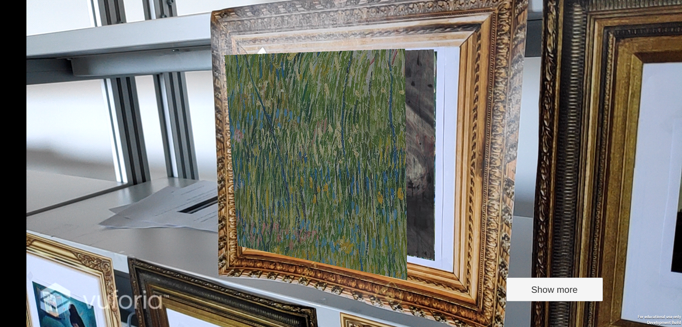

Figure 5

Originally, we were planning to use the swipe function of the image, but we had trouble of implementing gesture interactions, so we had to find another way to make it work. We figured out if we rotate the image by 180 the image on the other side does not have any texture so it will not show anymore.

The next step was to show some information about the original image, but also about the hidden image. To display the hidden text, initially our aim was to reveal after the hidden image when tapping on the top of the image. However, as the text is originally made on canvas it will always overlay in the front. For this reason, we create on Click event where the user will be able to press on Show more, to show the hidden text.

To place this much information on a single page was a bit untidy. For this reason, we decided to use a scroll bar to scroll through the text down. Using the scroll bar saved us a lot of space and the text was more clear to read. Also, we could place as much information as needed for individual image, as we were not limited to the space anymore.

Figure6 bellow, shows the layout of the text and the scrollbar we designed for this application.

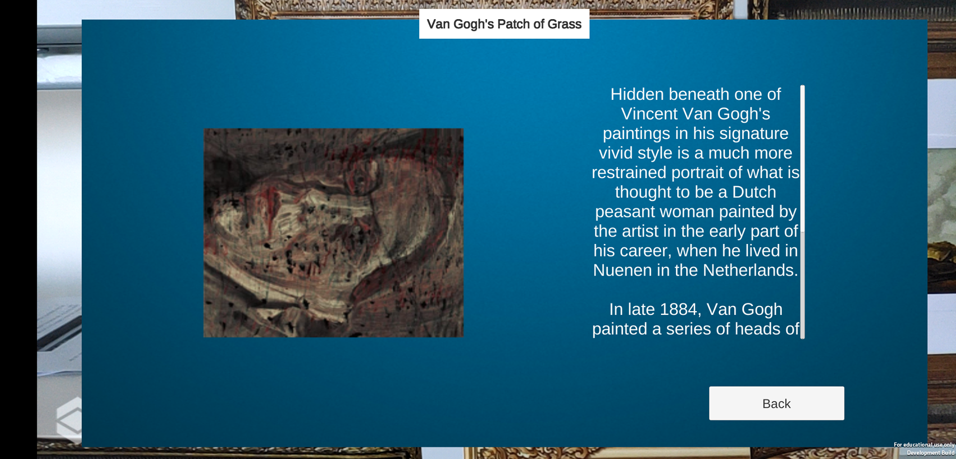

Figure 6

Once we have designed the canvas with more information, it was unable to go back out of it. In this case, we created a Back button for the user to go back to see the original and hidden image, otherwise, the canvas was showing every time the image was recognized for the second time.

Once it was working on single image we implemented it on another 7 pieces which made 8 different pieces in total for this application. When all the components were working correctly, we demonstrated the application on an Android device.

Later on, we build the project into the mobile phone. When we were testing the application on the phone, the text and buttons on the canvas were very small. For this reason, we had to update the font size. It was big enough on the computer, however, not big enough for a mobile app.

# Team working

On this project I was collaborating with Nicholas Fitton. Nicholas and I decided to visit the museum and gallery together. As I was working with Nicholas before as we were very organized and we did not have any issues on weekly meetings which allowed us to work on the project together. Once we agreed on the project idea, we break down the tasks so we do not lose any time working on the same things. We always meet to put the tasks together and discuss if we came across some issues and tried to figure them out together.

# Conclusion

In this project we learned a lot out Unity. Even though we did not manage to implement all features like swipe function, we managed to find ways to achieve our goals to create a mobile application for the gallery, which will provide more information, especially revealing the hidden art image and provide the visitors with more interaction that visitors can enjoy.

# References

1. Bbc.co.uk. (2018). *BBC - - Media Centre*. [online] Available at: https://www.bbc.co.uk/mediacentre/latestnews/2018/civilisations-ar-launches?lang=gd [Accessed 2 Apr. 2019].
2. Marques, D. (2004). *Skin & Bones Augmented Reality mobile app at the Smithsonian's Natural History Museum • Diana Marques*. [online] Diana Marques. Available at: https://www.dianamarques.com/portfolio/augmented-reality-app-skin-bones/ [Accessed 1 Apr. 2019].
3. ZHANG, M. (2010). *Museum of London Releases Augmented Reality App for Historical Photos*. [online] PetaPixel. Available at: https://petapixel.com/2010/05/24/museum-of-london-releases-augmented-reality-app-for-historical-photos/ [Accessed 1 Apr. 2019].
4. Callahan, S. (2018). *The Art World's Secrets Finally Revealed Thanks To Technology*. [online] Culturacolectiva.com. Available at: https://culturacolectiva.com/art/art-worlds-secrets-that-were-solved-thanks-to-technology [Accessed 27 Mar. 2019].